Mainframe Technology – COBOL, JCL & VSAM Assessment

SCENARIO NUMBER 6. MINIMUM BALANCE PENALTY PROCESSING SYSTEM

NAME: HARIPRASAD N

VSAM DATASET:

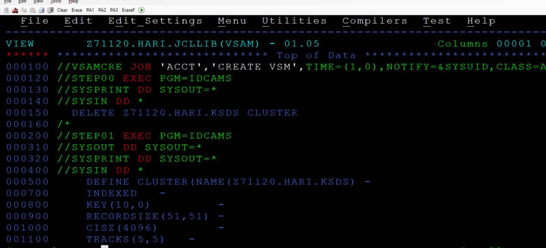

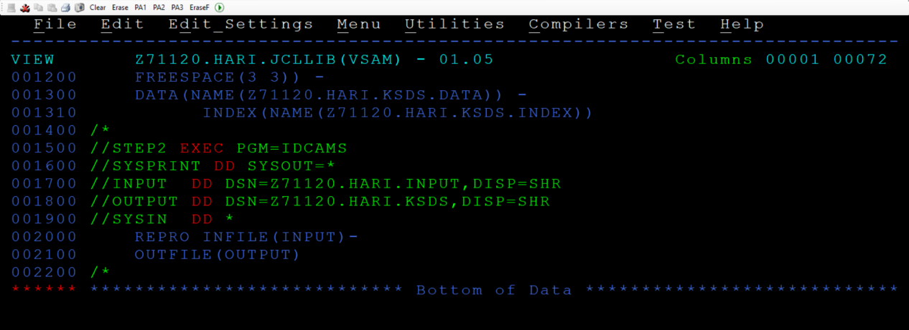

JCL CODE: 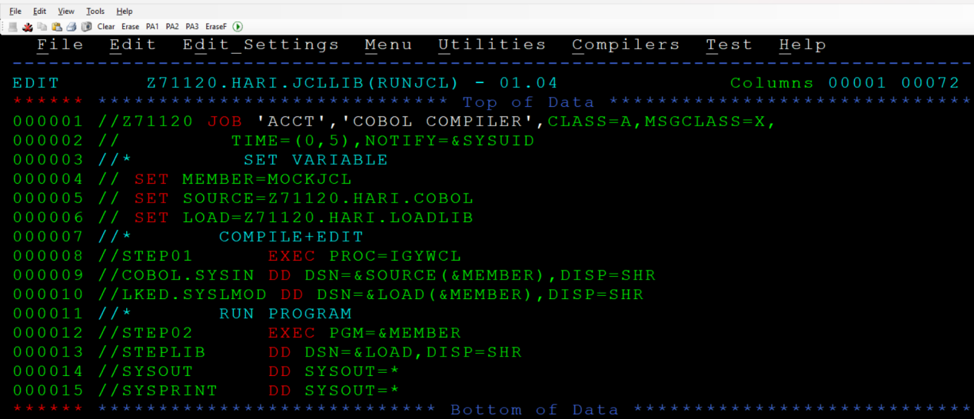

COBOL CODE:

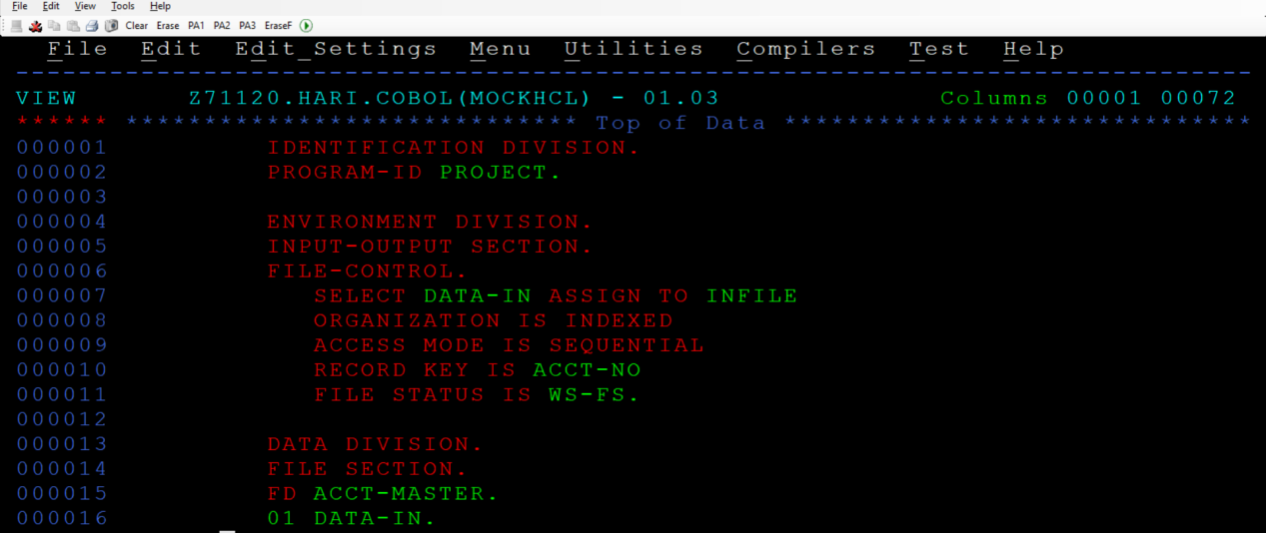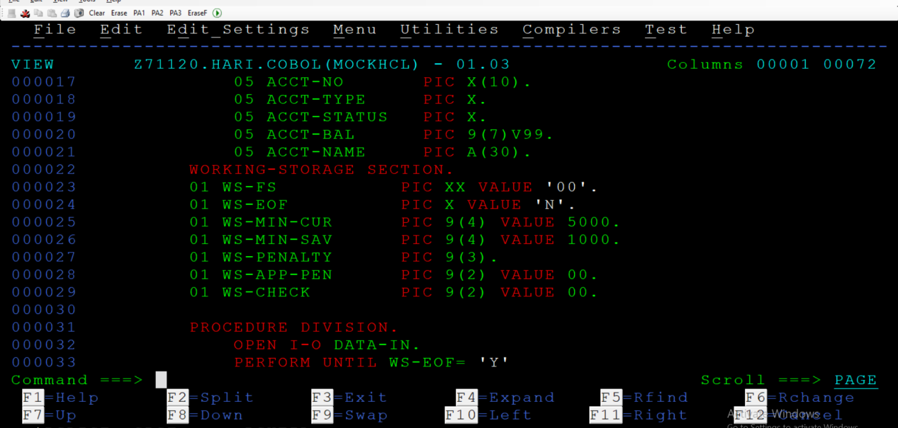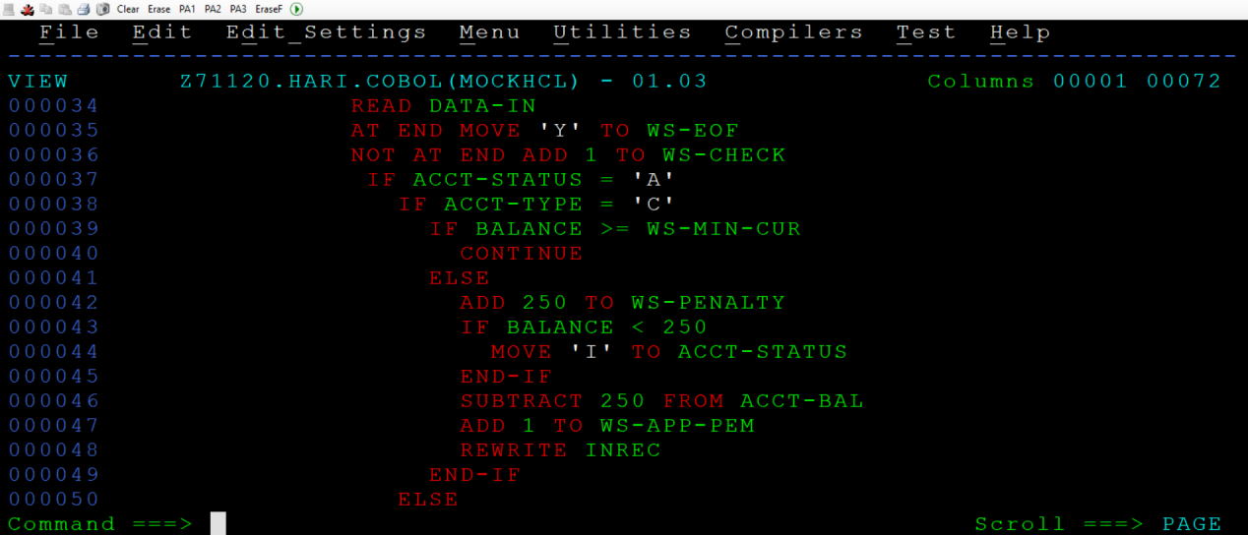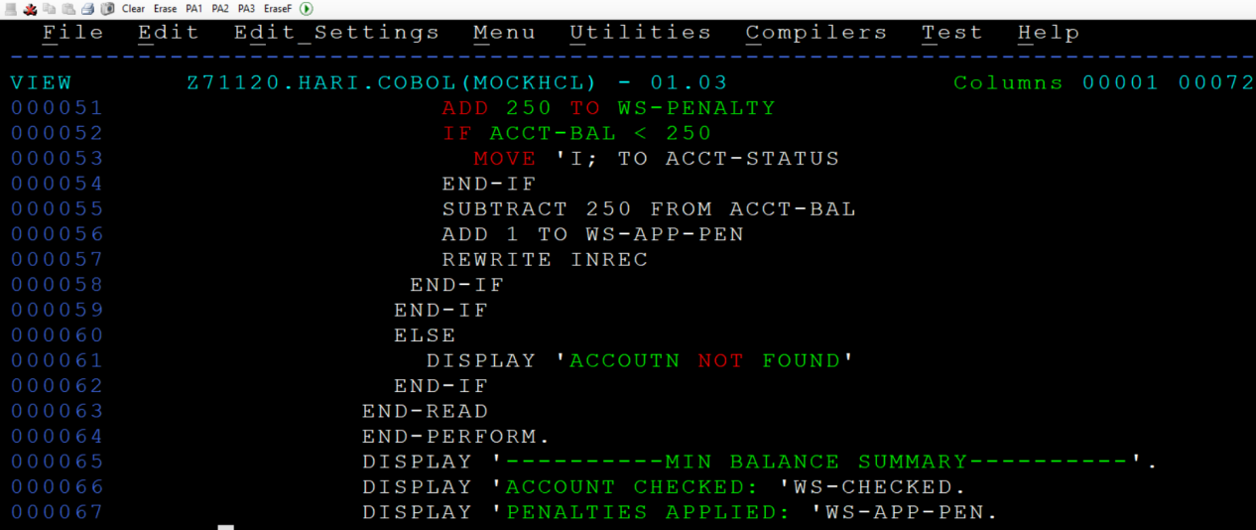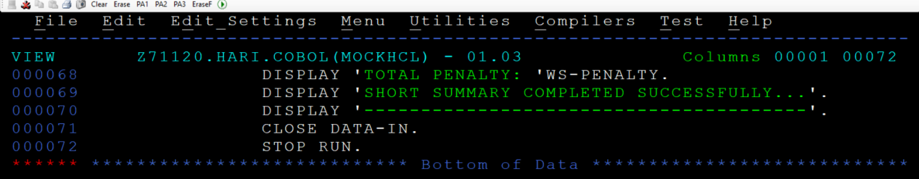

OUTPUT:
